Cost of Living in the US
Final Data Project (DATA 380)

By: Ethan Pac
Due Date: May 4th, 2026
Class: DATA-380TA-01 Data visualization with Python

Data Analysis
The US Family Budget Dataset contains cost-of-living estimates for different family types across counties and metro areas in the United States. The variables that are included in this dataset include: Categorical (state, isMetro, areaname, county), Quantitative (family_member_count, housing_cost, food_cost, transportation_cost, healthcare_cost, other_necessities_cost, childcare_cost, taxes, total_cost, and median_family_income.) The variable case_id was excluded from analysis because it serves only as an identifier for the data. For data cleaning I checked for missing values and then removed those values using (df = df.dropna()).

Summary Table

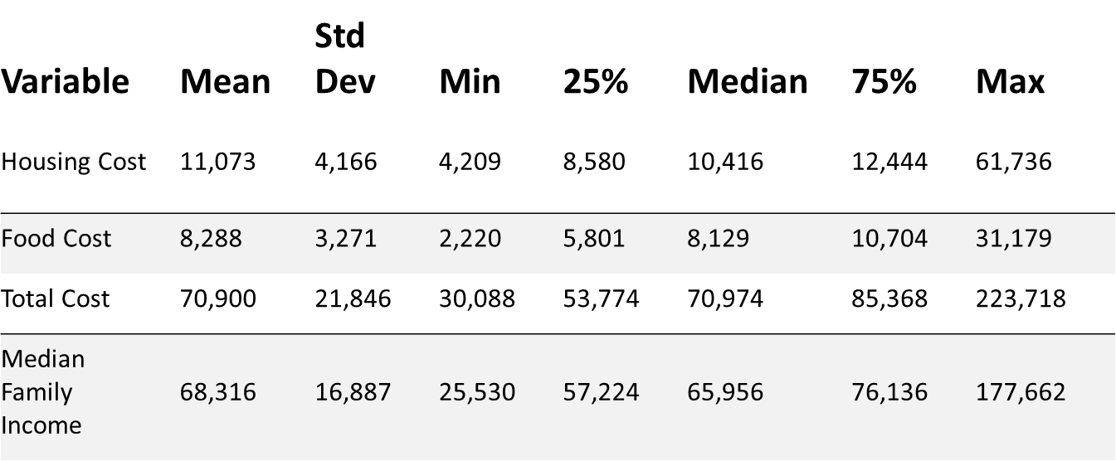
If you look at the table here you can see that the biggest difference between min and max is the total cost, Median family income and housing cost have the next biggest difference. Food cost has the lowest difference between min and max. With the range being so wide between total cost, housing cost, and median family income, and with the median being much lower than the max it tells us that there are definitely some outliers that skew the max in a high direction. It makes sense that food costs have the lowest difference because everyone needs food. Because of this, those costs will not be as significant as the places you live, the total cost with taxes and schooling included, as well as your median income where your job plays a big role in that number. All those variables just described have a lot of difference depending on where you live in the country. Those differences are still evident in food costs, but are not nearly as high as explained in the summary table.

State Level Analysis
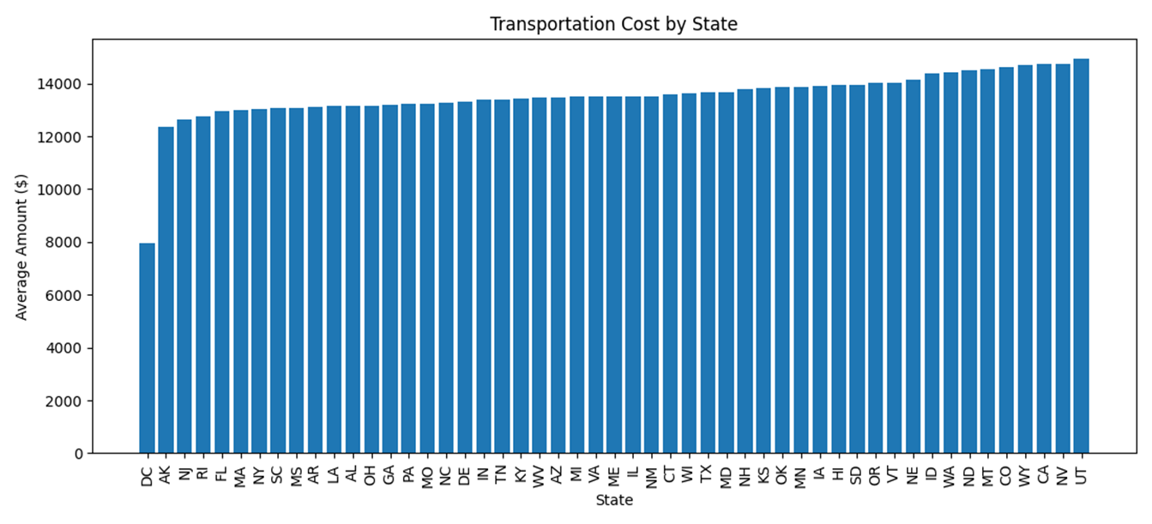
This graph shows the average transportation cost in each state. It is ranked from lowest to the highest going left to right. Overall, transportation costs are fairly even across all states, especially compared to some other variables. However, you do have some differences. The lowest state is Washington, D.C., with an average transportation cost around $8,000, which is much lower than the rest of the states. This could be due to the high number of public transportation offered, which would allow families to spend less on private vehicle costs. After D.C., states such as Alaska, New York, Rhode Island, Hawaii, Massachusetts, New Jersey, South Carolina, Vermont, and Arkansas are on the lower end, mostly around $12,000 to $13,000. Looking forward, most states fall in the middle range, between $13,000 and $14,000. Some states that fall in that range include Ohio, Georgia, North Carolina, Delaware, Texas, and Maryland. The highest transportation costs range roughly between $14,000 to $15,000. Some states that fall in this grouping include Utah, California, Colorado, Oregon, and Minnesota. These states at the end could be more expensive due to the longer commute distance or stronger reliance on personal vehicles to go from one place to another. 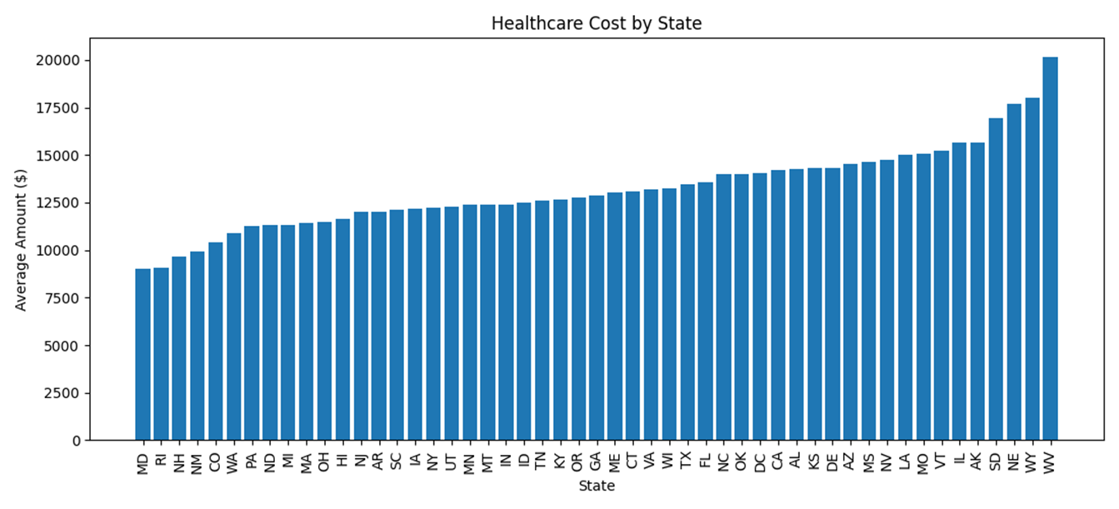
This graph shows the average healthcare cost by state. The differences in comparison to transportation are much larger. The lowest healthcare costs are seen in states like Maryland, Rhode Island, Colorado, Ohio, New Jersey, South Carolina, and New York. These states' costs lay between the $9,000 to $12,000 range. The next large group of states falls in the middle range, with costs being between $12,000 to $14,500. These include states such as Tennessee, Kentucky, Georgia, Maine, Connecticut, Virginia, D.C., and California. The states in this section all have very similar healthcare costs. The highest healthcare costs appear in West Virginia, Nebraska, South Dakota, New Hampshire, and Wyoming, with Wyoming being the highest at around $20,000. This is a major increase from the lower-cost states. The graph suggests that healthcare costs are one of the more uneven expenses across states. Some states have healthcare costs almost twice as high as others, which can heavily impact a families budget.
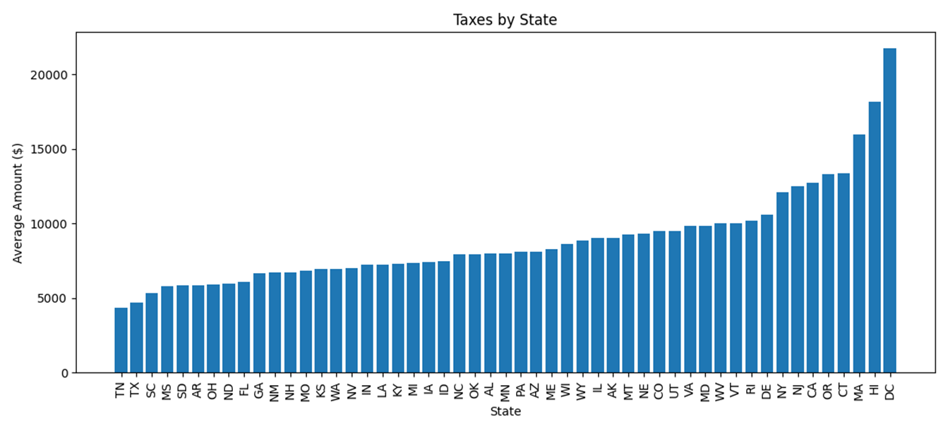
This graph shows the average taxes by state, and out of these first few graphs it has one of the most consistent upward trends. The lowest tax levels are found in states like Tennessee, South Carolina, Mississippi, South Dakota, Arkansas, and Ohio. These states are generally under or around $7,000 to $8,000. The middle range includes states like North Carolina, Oklahoma, Wyoming, Minnesota, Pennsylvania, Arizona, Maine, and Florida. These states mostly fall between $8,000 and $10,500. The highest tax states are D.C., Massachusetts, Hawaii, Connecticut, California, New Jersey, New York, and Washington, D.C. is the highest, at over $21,000, followed by Massachusetts and Hawaii. This graph shows that taxes vary widely across states and regions. The highest-tax states are often places with higher incomes and higher overall costs of living. The relationship makes a lot of sense because taxes can rise when incomes, housing values, and total living costs are also high. It also connects well to the later scatterplots, especially median family income vs. taxes and housing cost vs. taxes, because higher-cost areas often have higher tax burdens so they pay more money.

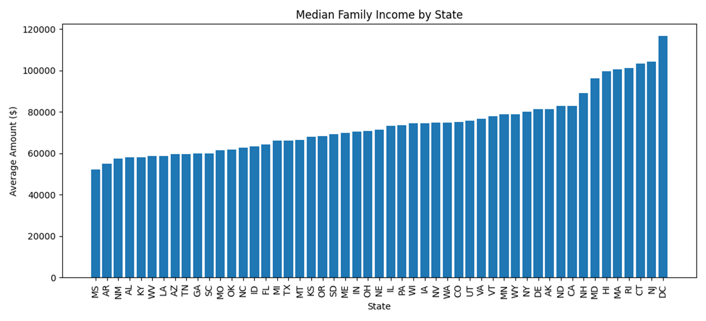
This graph shows the average median family income by state, ranked from lowest to highest and from left to right. The lowest median family income appears in Mississippi, around $52,000, followed by states like Arkansas, New Mexico, Alabama, Kentucky, and Texas. These states are mostly in the $50,000 to $65,000 range. The middle group includes states like Minnesota, Kansas, Oregon, South Dakota, Maine, and Indiana These states generally fall between about $65,000 and $85,000. The highest median family incomes are found in Washington, D.C., Connecticut, New Jersey, Massachusetts, Rhode Island, Hawaii, Maryland, and New Hampshire. D.C. is the highest, at around $116,000, which is far above the lower-income states. Maryland, Massachusetts, New Jersey, and Connecticut are also high, close to or above $100,000. This graph showcases that income levels are very different across states. Most of the states with high income appear high in taxes, childcare, and housing costs as well. Because of this, we can conclude that higher income does not always mean families are better off financially. Higher-income areas often come with higher expenses.
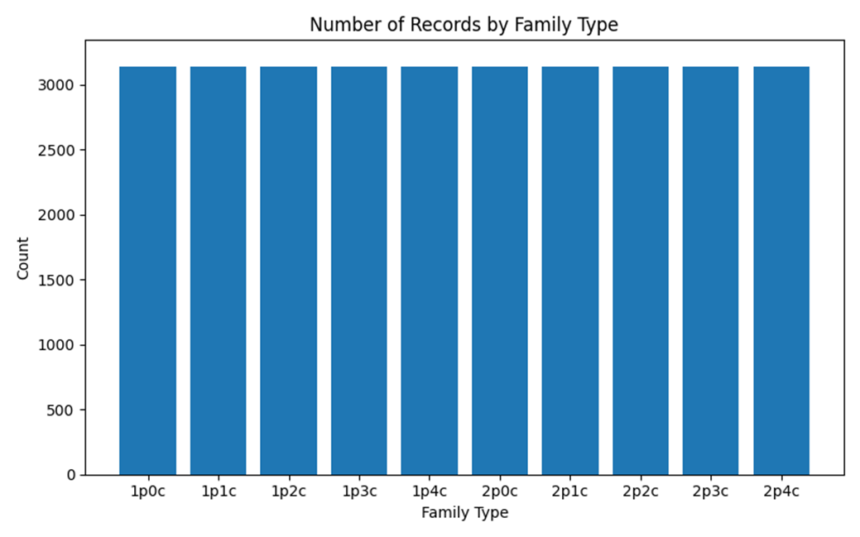
Looking at this graph you see that everything is even. This is because when the dataset was recorded it made sure to have the same number family types to keep the data from being biased. You have single parent families with up to four kids and you have double parent families with up to 4 kids. No family type, as said before, is heavily overpresented or underrepresented. This data is fairly represented which is helpful for analyzing cost of living based on family size.

Grouped Table by State
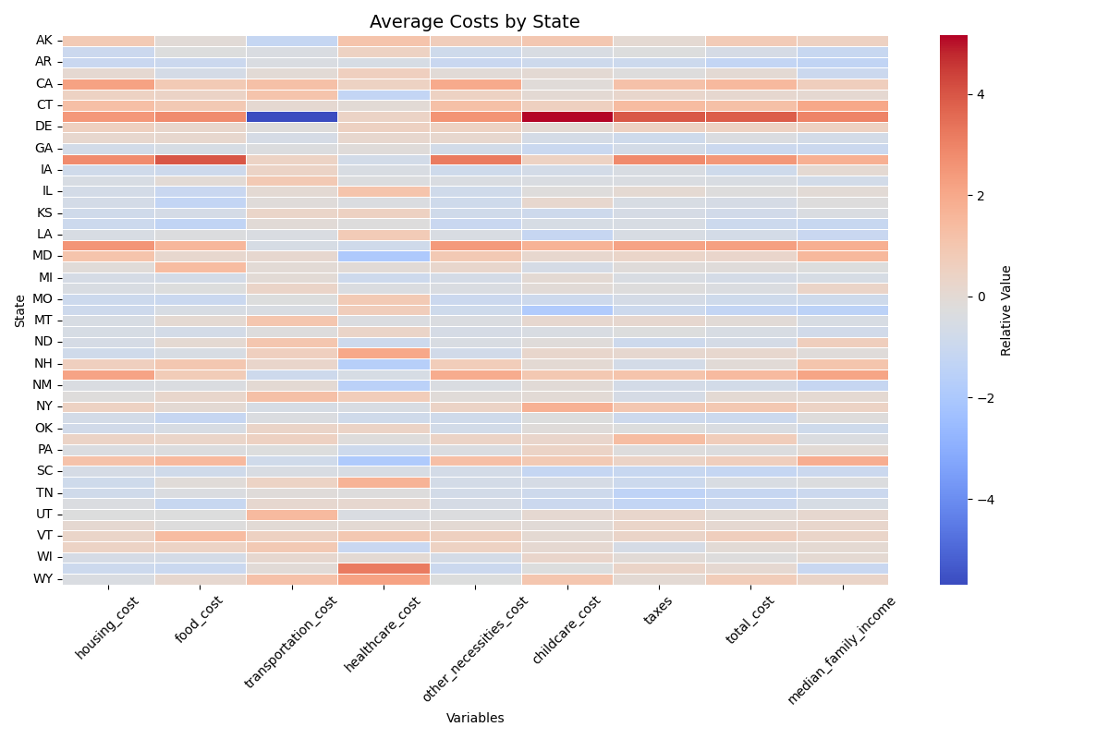
This heatmap shows the average costs by state for housing, food, transportation, healthcare, childcare, taxes, total cost, and median family income. The red areas mean the state is higher than average, while the blue areas mean it is lower than average. Overall, states like D.C., California, Massachusetts, New York, New Jersey, Connecticut, and Maryland seem to have higher costs and higher incomes. States like Mississippi, Arkansas, Tennessee, South Carolina, and Louisiana are lower in several categories. Some states are not shown on the y-axis because there was not enough room to label every state clearly on the graph. The main takeaway is that states with higher incomes usually also have higher living costs. As well as, the northeast tends to be much more expensive than the southern states.
Choropleth Map
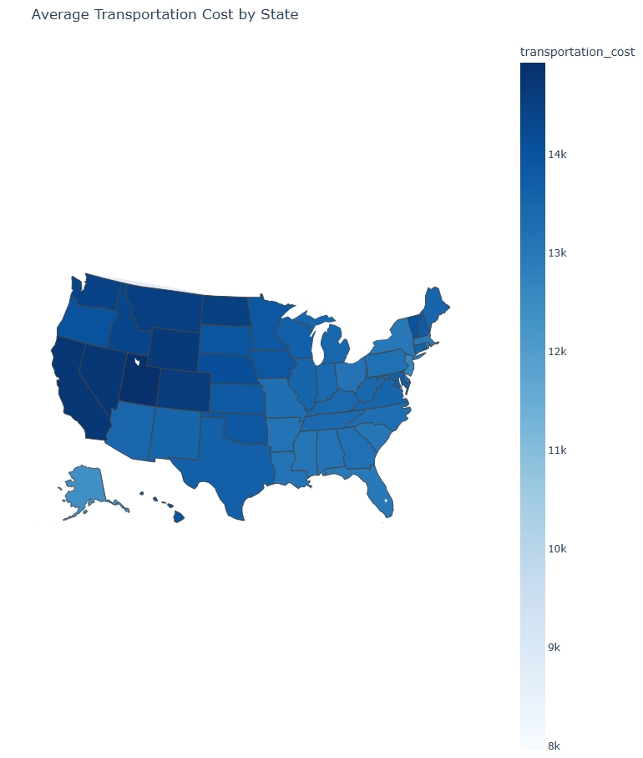
This map shows the average transportation cost by state. Darker blue states have higher transportation costs, while lighter blue states have lower costs. The West definitely has higher transportation costs than other regions. This includes states like California, Washington, Oregon, and Montana. Some lighter states, such as Alaska and parts of the midwest area, appear lower. The northeast also has some areas that appear high like Maryland and Vermont. Transportation costs vary by state, but the differences are not as extreme as taxes or childcare and this graph helps show that it is not as significant.
Scatterplots by State
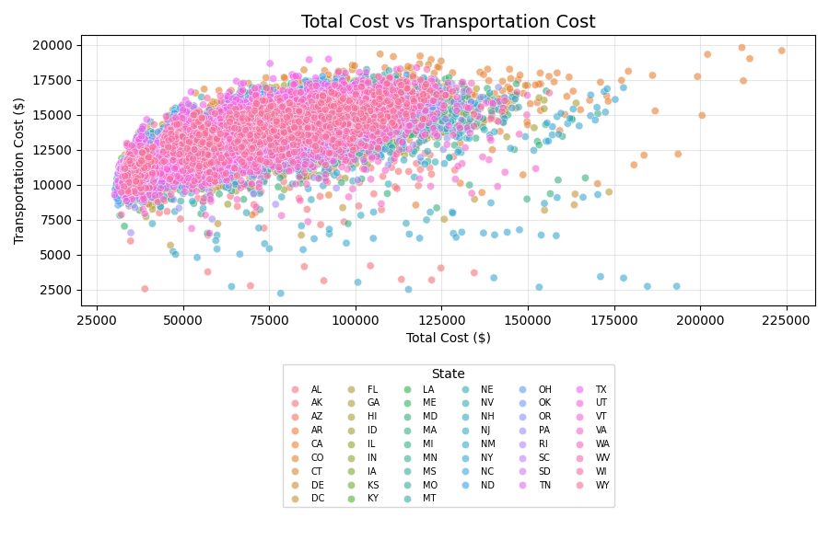
This scatterplot shows a slight positive relationship between total cost and transportation cost. As total cost increases, transportation cost also tends to increase a little, but the pattern is not strong. Most points are clustered between about $40,000 and $120,000 in total cost and $9,000 to $17,000 in transportation cost. Because of this, we can see that transportation is part of the total cost, but it is not the only major factor driving overall living expenses and it is definitely not the most impactful on those expenses.
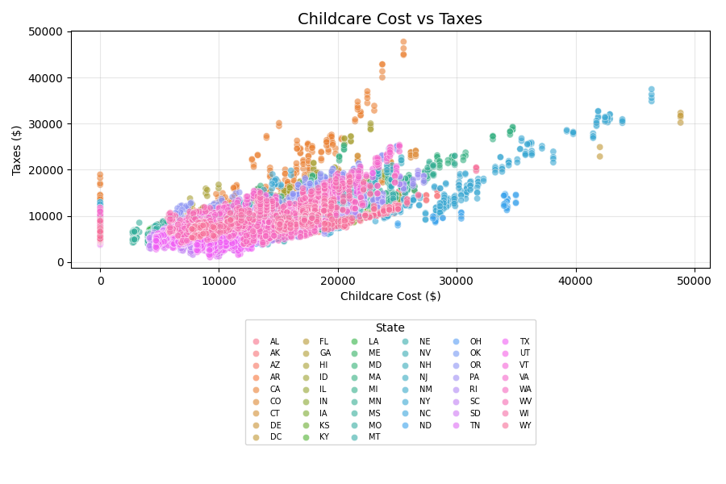
This graph shows a positive relationship between childcare costs and taxes. In general, as childcare costs rise, taxes also tend to increase. All counties are represented but their states are dot. Most of these counties are clustered between about $5,000 and $25,000 in childcare costs, but there are some clear outliers with childcare costs above $35,000 and taxes above $30,000. We can conclude that those areas with higher taxes also tend to have higher childcare costs. Furthermore, you see a lot of those northeast states having high childcare costs, this could be due to the large amount of private and prep schools in those areas.
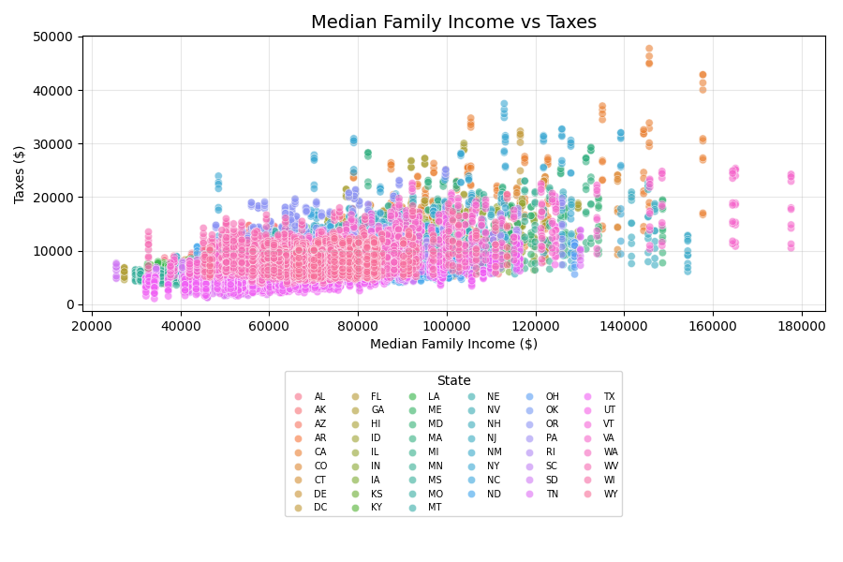
This scatterplot shows that taxes tend to increase as median family income increases. Most counties, represented by their state dot, are grouped between $50,000 and $120,000 in median family income, with taxes mostly below $20,000. However, there are some high-income areas with taxes above $30,000 and $40,000. The higher-income places usually have higher taxes, but the relationship is not perfect because taxes also depend on state and local cost. Last;y, states with higher median family income tend to vary across regions and not one dominates the rest.
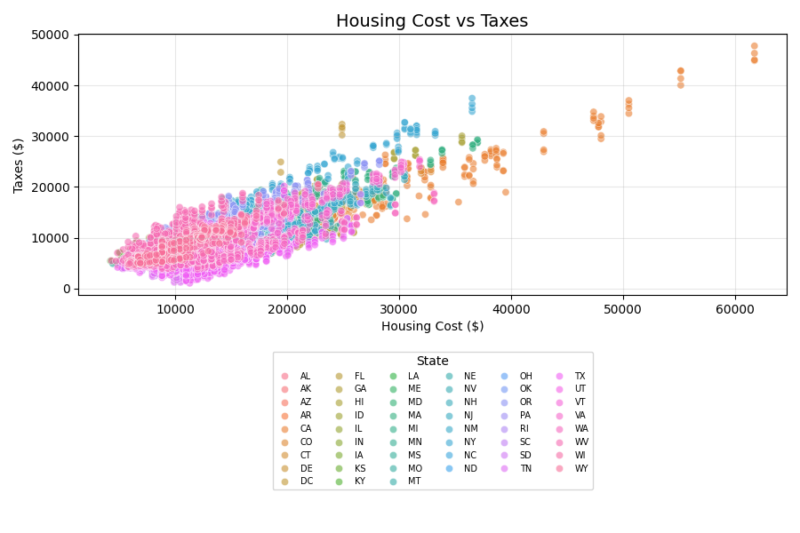
This graph shows a clear positive relationship between housing costs and taxes. As housing costs increase, taxes also tend to rise. Most counties are clustered between about $8,000 and $30,000 in housing costs, but there are some expensive areas above $40,000 and almost to near $60,000. This is one of the stronger patterns because housing is closely connected to income, property values, and overall cost of living. You see some states like DC and Illinois with higher housing costs, this could be due to large cities, where housing is often more expensive.

Most Expensive Counties for Childcare / Counties with Highest Taxes
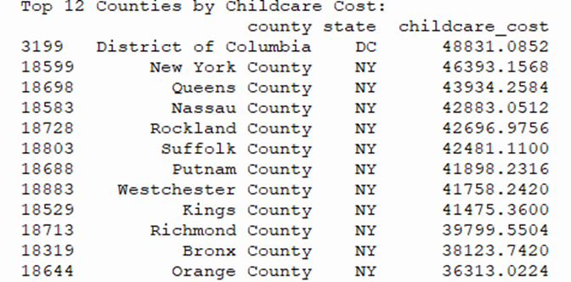
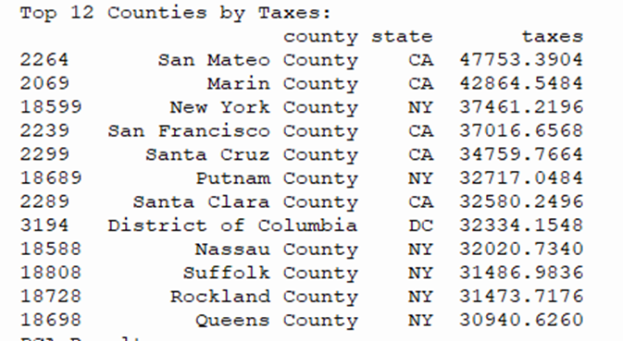
When looking at both of these charts you can see that the dominant states for both are New York and Californa. DC works its ways in there a little, but that's due to a lack of information about the area in the dataset making it a big outlier. The counties with the highest childcare costs are almost entirely in NY, where schooling is usually private which costs a lot of money. The counties with highest taxes both fall into the states NY and CA, but counties in CA are more at the top possible due to those areas being on the coast.
Correlation Matrix
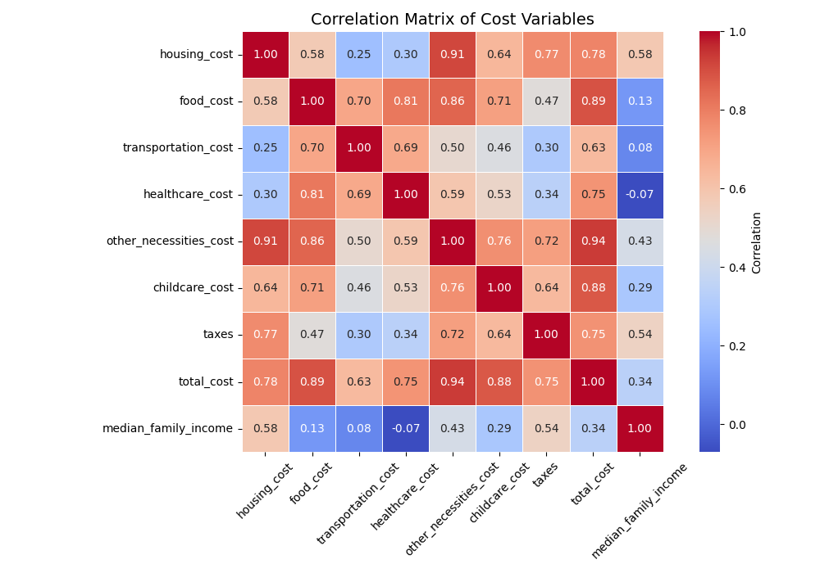
This correlation matrix shows how strongly the cost variables are related to each other. The strongest relationships are between total cost and other necessities cost, total cost and food cost, total cost and childcare cost, and housing cost and other necessities cost. The darker red values show that when one of these costs increases, the other usually increases too. The matrix also shows that median family income has weaker relationships with some cost variables, especially transportation and healthcare. The main takeaway from the graph is that total cost is most closely connected to basic living expenses like housing, food, childcare, and other necessities. This means these categories are major drivers of the overall cost of living. Which makes a lot of sense because you need those basic living expenses to live healthy lives.
Regression Line
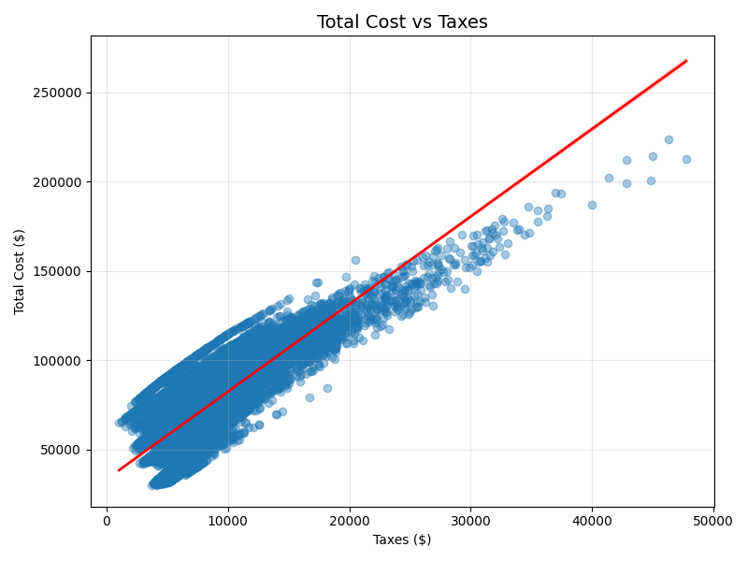
This graph shows the relationship between total cost and taxes with a regression line. The upward red line shows a strong positive relationship, meaning that as taxes increase, total cost also tends to increase. Most points are clustered below $120,000 in total cost and below $15,000 in taxes, but there are some high-cost outliers above that range. Taxes are strongly connected to total cost, but they are not the only factor because other costs like housing, childcare, food, and healthcare also add to the total. As seen in graphs before, certain variables contribute more to the total cost than others, but all play a role.
Outliers for Food Cost by State
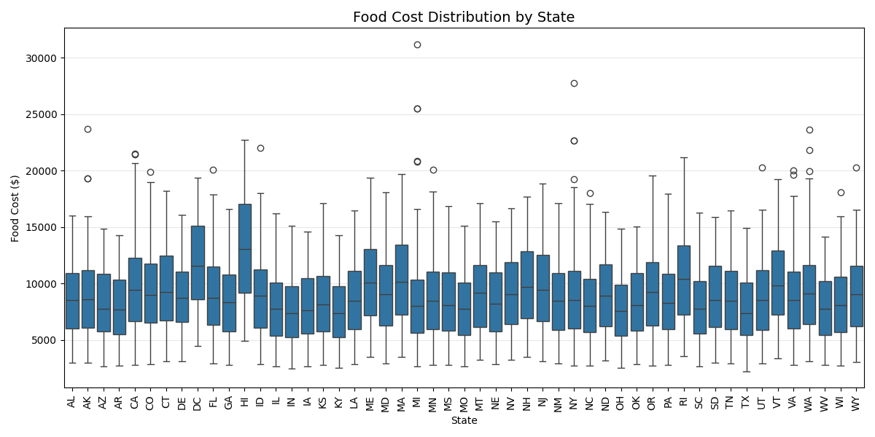
This boxplot shows how food costs are spread out in each state. Most states have a similar middle range, with many food costs falling around $6,000 to $12,000. Some states have higher outliers, meaning a few counties or family types have much higher food costs than the normal range. States like Minnesota, North Carolina, Alaska, Colorado, and Washington show some of the larger outliers. Hawaii also has the highest range of food cost with the highest ceiling and floor. This could be due to the very high level of tourism in Hawaii. Overall, food costs vary by state, but the main pattern is that most states have a similar average range with a few high-cost cases which have no specific pattern.
Bubble Plots
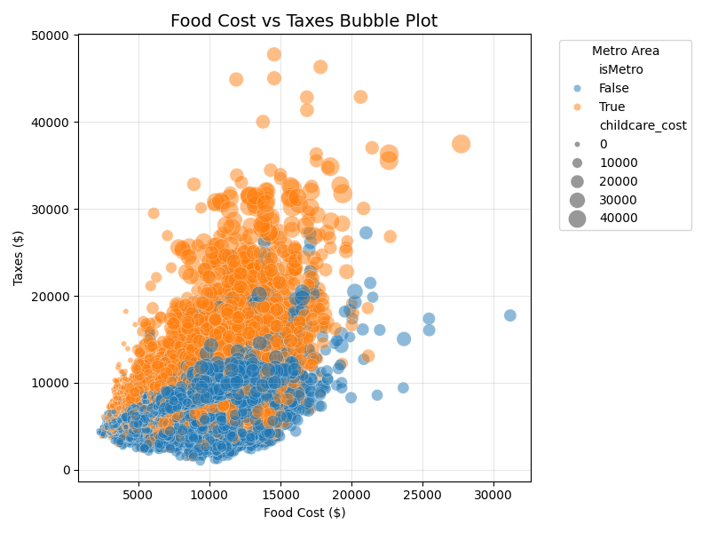
This bubble plot compares food costs and taxes. The color shows whether the area is metro (Orange) or non-metro (Blue), and the bubble size is based on childcare cost and the number range it falls into. The graph shows that metro areas usually have higher taxes and higher food costs than non-metro areas. The larger bubbles also appear more often in the higher-tax areas, which means childcare costs are usually higher where taxes and food costs are higher. Coming from a big family I know our food cost is pretty high as well as our taxes. We also live in a metro area so my family would fit in the trend of this bubble plot.
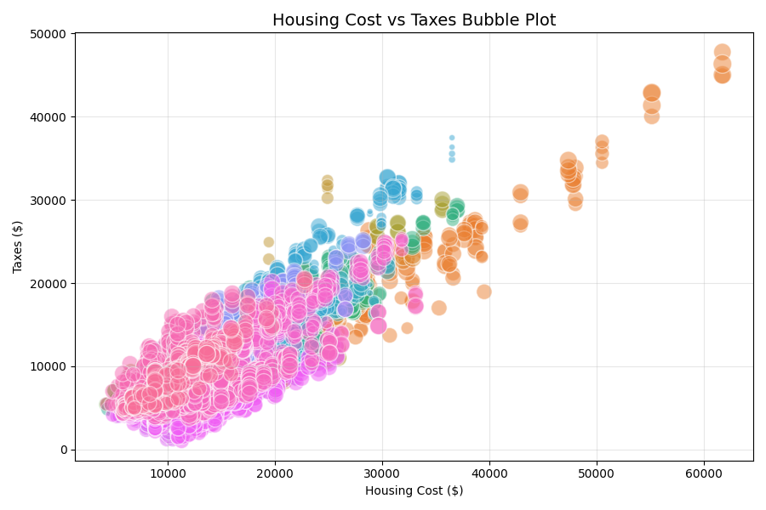
This graph shows a clear positive relationship between housing costs and taxes. As housing costs increase, taxes also usually increase. The larger bubbles represent higher transportation costs, and many of the larger-cost areas are toward the upper-right side of the graph. The colors are similar to the scatterplot in each represents a state, which then has multiple counties. Counties with expensive housing often also have higher taxes and higher transportation costs. Housing is definitely one of the strongest cost drivers in the dataset.

3D Plots
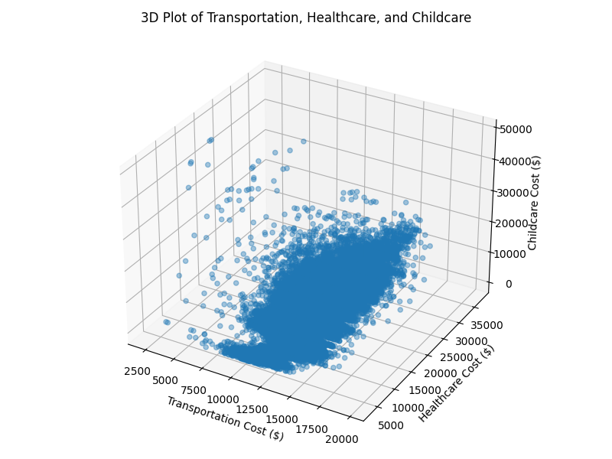
This 3D plot compares transportation cost, healthcare cost, and childcare cost at the same time. Most points are clustered in the middle, meaning many counties have similar cost levels across these three categories. There are also some outliers where childcare or healthcare costs are much higher than the rest. The graph shows that some counties face multiple high costs at once, but childcare has the largest spread when compared to transportation and healthcare.
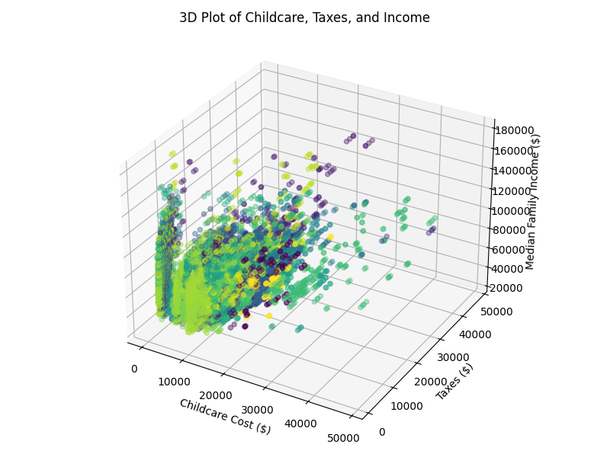
This 3D plot shows the relationship between childcare cost, taxes, and median family income. Most points are clustered at lower to middle childcare and tax levels, but there are some clear high-cost outliers. In general, areas with higher childcare costs also tend to have higher taxes and higher median family income. This suggests that higher-income areas often come with higher living expenses, especially for families with children which makes sense. More kids means more rooms, which means bigger houses and more living expenses.

PCA and NMF
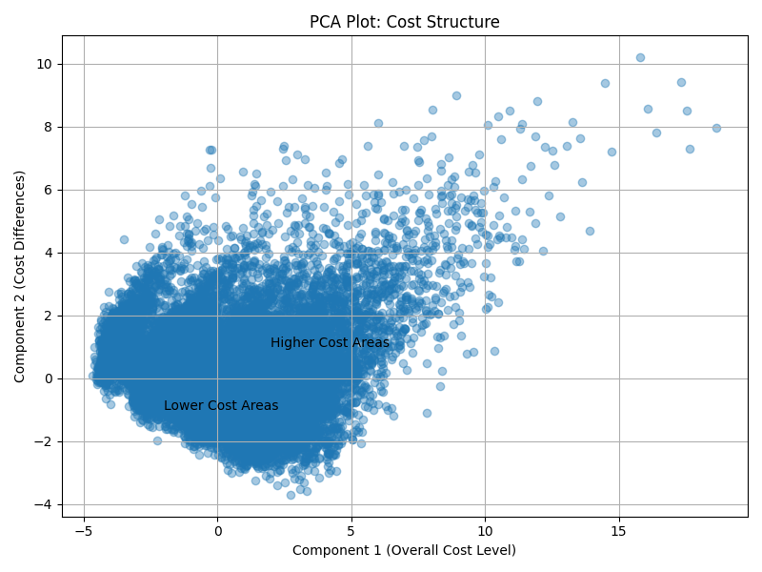
This PCA plot is used to simplify the cost-of-living dataset by reducing many cost variables into two main components. Component 1 represents the overall cost level, so the points farther to the right are usually higher-cost areas, while points farther to the left are lower-cost areas. Component 2 represents differences in the structure of costs, this means that some places' costs may be higher because of childcare, healthcare, transportation, housing, or taxes. Most of the points are clustered in the lower and middle part of the graph, which showcases that many of the counties have similar cost structures no matter the state. However, some points are farther to the right and higher up, which represent areas with much higher overall costs or unusual cost patterns. The labels “Lower Cost Areas” and “Higher Cost Areas” are meant to help show the general direction of the graph, but the plot is definitely crowded due to the dataset having over 31,000 records. PCA does not show one specific variable by itself. Instead, it gives a broad summary of the overall cost pattern across the dataset. The main takeaway from this graph is that most counties are grouped together when it comes to cost, while a smaller number of high-cost areas stand out as outliers which you have seen in areas like DC, New York, and California.
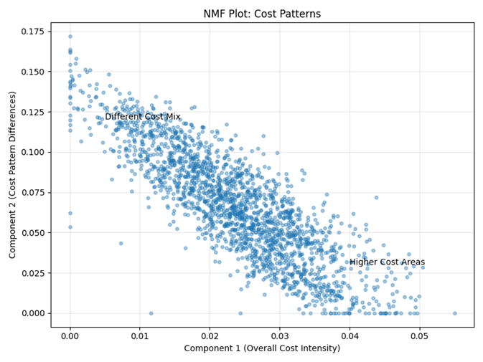
This NMF plot was used to find different cost patterns in the dataset. Component 1 represents overall cost intensity, so points farther to the right on the graph generally represent higher-cost areas. Component 2 represents differences in the cost pattern, which means areas may have different mixes of expenses, such as housing, childcare, transportation, healthcare, or taxes. Most of the points form a downward pattern. That is as the overall cost intensity increases, the second cost pattern becomes less important or changes direction and decreases. Points on the right side of the graph are higher-cost areas, while points near the upper-left are places with a different cost mix. The graph is a little crowded because the dataset has a lot of observations, but it still shows that most places follow a similar cost pattern, while a smaller number of areas stand out as having a higher-cost or a mix of different costs.
Conclusion and Reflection
Overall, this project shows that the cost of living in the United States changes a lot depending on the state, county, and family type. After cleaning and analyzing the data and different variables, it became clear that cost of living is based on multiple factors, not just one. The overall cost is made up of many connected costs, including housing, food, transportation, healthcare, childcare, taxes, and median family income. One of the biggest things I have found was that higher-income areas usually also have higher expenses. States such as D.C., California, and New York as well as some other cities in the northeast often appeared near the higher end for costs like childcare, taxes, housing, and total cost. These areas may have higher median family incomes, but families also face much higher living expenses due to the high value land in which they live on. On the other hand, southern states like Mississippi, Tennessee, South Carolina, and Louisiana for the most part had lower average costs, but also tended to have lower median family incomes. The graphs also showed that certain expenses vary more so than others do. Transportation costs were fairly similar across most states, while childcare, taxes, healthcare, and housing showed much larger differences depending on the area. Childcare stood out as one of the most unequal costs, especially in places like D.C. and Massachusetts. The scatterplots and correlation matrix showed that total cost is strongly connected to housing, food, childcare, taxes, and other necessities. The regression graph also showed a positive relationship between taxes and total cost, which means the higher the taxes is, the higher the overall costs tends to be. The PCA and NMF graphs helped summarize the larger patterns in the dataset. Both graphs were crowded and sloppy in certain aspects because of the large dataset, but they still accomplished showing that most counties fall into a similar cost range, while a smaller number of high-cost areas stand out. In conclusion, this project shows that cost of living is very different across the United States. A family’s financial situation depends not only on how much money they make, but also on where they live and what expenses are highest in that area or region. States with higher income may seem more appeasing to live in, but higher housing, childcare, tax, and total living costs come with it. This project helped me better understand how data visualization can be used to find patterns, compare states, and read graphs. It was difficult at times but overall once you get the code down all you have to do is explain it so the audience knows what you're talking about.

Appendix
import pandas as pd
import matplotlib.pyplot as plt
import seaborn as sns
from sklearn.preprocessing import StandardScaler
from sklearn.preprocessing import MinMaxScaler
from sklearn.decomposition import PCA
from sklearn.decomposition import NMF
import plotly.express as px
from mpl_toolkits.mplot3d import Axes3D

# Load the dataset
df = pd.read_csv(r"C:\Users\pace\Downloads\cost_of_living_us.csv")

# Clean the data
df = df.dropna()

# Drop case_id because the assignment says to skip it
df = df.drop("case_id", axis=1)

# Check the data
print(df.shape)
print(df.head())
print(df.info())

# Separate variables
categorical_vars = ["state", "isMetro", "areaname", "county", "family_member_count"]

quantitative_vars = [
"housing_cost",
"food_cost",
"transportation_cost",
"healthcare_cost",
"other_necessities_cost",
"childcare_cost",
"taxes",
"total_cost",
"median_family_income"
]

print("Categorical variables:")
print(categorical_vars)

print("\nQuantitative variables:")
print(quantitative_vars)

# Summary statistics
print("\nSummary statistics:")
print(df[quantitative_vars].describe())

# Missing values check
print("\nMissing values:")
print(df.isnull().sum())

# Summary table by state
state_summary = df.groupby("state")[quantitative_vars].mean()
print("\nAverage cost values by state:")
print(state_summary)

# Part 3: Graphs by State
state_variables = [
"transportation_cost",
"healthcare_cost",
"childcare_cost",
"taxes",
"median_family_income"
]

for var in state_variables:
state_avg = df.groupby("state")[var].mean().sort_values()

plt.figure(figsize=(11, 5))
plt.bar(state_avg.index, state_avg.values)
plt.title(var.replace("_", " ").title() + " by State")
plt.xlabel("State")
plt.ylabel("Average Amount ($)")
plt.xticks(rotation=90)
plt.tight_layout()
plt.show()

# Part 3: Family Member Count Graph
family_counts = df["family_member_count"].value_counts().sort_index()

plt.figure(figsize=(8,5))
plt.bar(family_counts.index, family_counts.values)
plt.title("Number of Records by Family Type")
plt.xlabel("Family Type")
plt.ylabel("Count")
plt.ylim(0, max(family_counts.values) + 200)
plt.tight_layout()
plt.show()

# Part 4: Group by State Using Color
state_table = df.groupby("state")[quantitative_vars].mean()

scaler = StandardScaler()
scaled_data = scaler.fit_transform(state_table)

scaled_df = pd.DataFrame(
scaled_data,
index=state_table.index,
columns=state_table.columns
)

plt.figure(figsize=(12,8))

sns.heatmap(
scaled_df,
cmap="coolwarm",
linewidths=0.5,
cbar_kws={"label": "Relative Value"}
)

plt.title("Average Costs by State", fontsize=14)
plt.xlabel("Variables")
plt.ylabel("State")
plt.xticks(rotation=45)
plt.yticks(rotation=0)
plt.tight_layout()
plt.show()

# Part 5: Choropleth Map Transportation Cost by State
state_transport = df.groupby("state")["transportation_cost"].mean().reset_index()

fig = px.choropleth(
state_transport,
locations="state",
locationmode="USA-states",
color="transportation_cost",
color_continuous_scale="Blues",
scope="usa",
title="Average Transportation Cost by State"
)

fig.update_layout(margin={"r":0, "t":40, "l":0, "b":0})

fig.show()

fig.write_html("transportation_choropleth.html")

# Part 6: Scatter Plots
# Part 6: Scatter Plots (Improved Legend Placement)
pairs = [
("total_cost", "transportation_cost"),
("childcare_cost", "taxes"),
("median_family_income", "taxes"),
("housing_cost", "taxes")
]

for x, y in pairs:
plt.figure(figsize=(9,6))

sns.scatterplot(
data=df,
x=x,
y=y,
hue="state",
alpha=0.6,
s=35
)

plt.title(f"{x.replace('_',' ').title()} vs {y.replace('_',' ').title()}", fontsize=14)
plt.xlabel(x.replace("_", " ").title() + " ($)")
plt.ylabel(y.replace("_", " ").title() + " ($)")

plt.legend(
title="State",
bbox_to_anchor=(0.5, -0.2),
loc="upper center",
ncol=6, # spreads legend horizontally
fontsize=7
)

plt.grid(alpha=0.3)
plt.tight_layout()
plt.show()

# Part 7: Top 12 UNIQUE Counties by Childcare Cost
top_childcare = (
df.sort_values(by="childcare_cost", ascending=False)
.drop_duplicates(subset=["county", "state"])
.head(12)
)

print("Top 12 Counties by Childcare Cost:")
print(top_childcare[["county", "state", "childcare_cost"]])

# Part 8: Top 12 UNIQUE Counties by Taxes
top_taxes = (
df.sort_values(by="taxes", ascending=False)
.drop_duplicates(subset=["county", "state"])
.head(12)
)

print("Top 12 Counties by Taxes:")
print(top_taxes[["county", "state", "taxes"]])

# Part 9: Correlation Matrix
corr = df[quantitative_vars].corr()

plt.figure(figsize=(10,7))

sns.heatmap(
corr,
annot=True,
cmap="coolwarm",
fmt=".2f",
linewidths=0.5,
square=True,
cbar_kws={"label": "Correlation"}
)

plt.title("Correlation Matrix of Cost Variables", fontsize=14)
plt.xticks(rotation=45)
plt.yticks(rotation=0)
plt.tight_layout()
plt.show()

# Part 10: Regression Line Total Cost vs Taxes
plt.figure(figsize=(8,6))

sns.regplot(
data=df,
x="taxes",
y="total_cost",
scatter_kws={"alpha":0.4},
line_kws={"color":"red", "linewidth":2}
)

plt.title("Total Cost vs Taxes", fontsize=14)
plt.xlabel("Taxes ($)")
plt.ylabel("Total Cost ($)")
plt.grid(alpha=0.3)
plt.tight_layout()
plt.show()

# Part 11: Outliers for Food Cost by State
plt.figure(figsize=(12,6))

sns.boxplot(
data=df,
x="state",
y="food_cost",
showfliers=True
)

plt.xticks(rotation=90)
plt.title("Food Cost Distribution by State", fontsize=14)
plt.xlabel("State")
plt.ylabel("Food Cost ($)")
plt.grid(axis="y", alpha=0.3)
plt.tight_layout()
plt.show()

# Part 12: Bubble Plot for Food Cost and Taxes
plt.figure(figsize=(8,6))

sns.scatterplot(
data=df,
x="food_cost",
y="taxes",
size="childcare_cost",
hue="isMetro",
alpha=0.5,
sizes=(20, 250)
)

plt.title("Food Cost vs Taxes Bubble Plot", fontsize=14)
plt.xlabel("Food Cost ($)")
plt.ylabel("Taxes ($)")
plt.legend(title="Metro Area", bbox_to_anchor=(1.05, 1), loc="upper left")
plt.grid(alpha=0.3)
plt.tight_layout()
plt.show()

# Part 13: Bubble Plot for Housing Cost and Taxes
plt.figure(figsize=(9,6))

sns.scatterplot(
data=df,
x="housing_cost",
y="taxes",
size="transportation_cost",
hue="state",
alpha=0.5,
sizes=(20, 250),
legend=False
)

plt.title("Housing Cost vs Taxes Bubble Plot", fontsize=14)
plt.xlabel("Housing Cost ($)")
plt.ylabel("Taxes ($)")
plt.grid(alpha=0.3)
plt.tight_layout()
plt.show()

# Part 14: 3D Plot for Transportation Healthcare and Childcare
fig = plt.figure(figsize=(8,6))
ax = fig.add_subplot(111, projection="3d")

ax.scatter(
df["transportation_cost"],
df["healthcare_cost"],
df["childcare_cost"],
alpha=0.4
)

ax.set_title("3D Plot of Transportation, Healthcare, and Childcare")
ax.set_xlabel("Transportation Cost ($)")
ax.set_ylabel("Healthcare Cost ($)")
ax.set_zlabel("Childcare Cost ($)")

plt.tight_layout()
plt.show()

# Part 15: 3D Plot for Childcare Taxes Median Family Income and State
fig = plt.figure(figsize=(8,6))
ax = fig.add_subplot(111, projection="3d")

state_colors = df["state"].astype("category").cat.codes

ax.scatter(
df["childcare_cost"],
df["taxes"],
df["median_family_income"],
c=state_colors,
alpha=0.4
)

ax.set_title("3D Plot of Childcare, Taxes, and Income")
ax.set_xlabel("Childcare Cost ($)")
ax.set_ylabel("Taxes ($)")
ax.set_zlabel("Median Family Income ($)")

plt.tight_layout()
plt.show()

# Part 16: PCA with 3 Components
from sklearn.decomposition import PCA
from sklearn.preprocessing import StandardScaler

X = df[quantitative_vars]

scaler = StandardScaler()
X_scaled = scaler.fit_transform(X)

pca = PCA(n_components=3)
pca_result = pca.fit_transform(X_scaled)

# create dataframe (THIS is what you were missing or not running)
pca_df = pd.DataFrame(pca_result, columns=["PC1", "PC2", "PC3"])

# now plot
plt.figure(figsize=(8,6))

plt.scatter(pca_df["PC1"], pca_df["PC2"], alpha=0.4)

plt.title("PCA Plot: Cost Structure")
plt.xlabel("Component 1 (Overall Cost Level)")
plt.ylabel("Component 2 (Cost Differences)")

plt.text(2, 1, "Higher Cost Areas", fontsize=10)
plt.text(-2, -1, "Lower Cost Areas", fontsize=10)

plt.grid(True)
plt.tight_layout()
plt.show()

# Part 17: NMF with 3 Components
from sklearn.decomposition import NMF
from sklearn.preprocessing import MinMaxScaler

X = df[quantitative_vars]

# NMF needs positive values, so I scaled the data from 0 to 1
nmf_scaler = MinMaxScaler()
X_nmf = nmf_scaler.fit_transform(X)

nmf = NMF(n_components=3, random_state=1, max_iter=1000)
nmf_result = nmf.fit_transform(X_nmf)

nmf_df = pd.DataFrame(
nmf_result,
columns=["Component 1", "Component 2", "Component 3"]
)

print("NMF Results:")
print(nmf_df.head())

# sample the data so the graph is easier to read
sample = nmf_df.sample(2000, random_state=1)

plt.figure(figsize=(8,6))

plt.scatter(
sample["Component 1"],
sample["Component 2"],
alpha=0.4,
s=15
)

plt.title("NMF Plot: Cost Patterns")
plt.xlabel("Component 1 (Overall Cost Intensity)")
plt.ylabel("Component 2 (Cost Pattern Differences)")

plt.text(0.04, 0.03, "Higher Cost Areas", fontsize=10)
plt.text(0.005, 0.12, "Different Cost Mix", fontsize=10)

plt.grid(alpha=0.3)
plt.tight_layout()
plt.show()

